HD 98649

HD 98649 is a 1.03 M☉, G4V star1. The CH survey reported a LPGP with a period of 10400 days, a minimum mass of 7 MJup and a high eccentricity of 0.86. Based on 68 RV CORALIE measurements obtained between 2003 and 2019, a study performed in 2019 (hereafter R19)1 reported a LPGP signal with a period of days, a minimum mass of MJup and an eccentricity of .

In the present study, in addition to the R19’s dataset, 3 HARPS RV measurements obtained between 2009 and 2019 were considered. DPASS and MCMC (1000 walkers and 400000 iterations) were used to fit the data. The period reported for HD 98649b in the R19 study was within the error bars associated with the values found in the present analysis. However, for the minimum mass and the eccentricity, larger samplings of solutions were found using MCMC with confidence intervals at 1-sigma between 6.6 and 9.4 MJup for the minimum mass and between 0.84 and 0.95 for the eccentricity. The fits are shown in Fig 1, and the corner plot in Fig 2, and the results summarized in Table 1.

Note that, recently, combining RV and Hipparcos/Gaia absolute astrometry data, a study performed in 20212 were able to estimate the orbital inclination, and thus the true mass, of HD 98649b. They found a period of days, an eccentricity of , an inclination of ° or °, and a mass of MJup.

Conclusion: The properties found in the CH survey for HD 98649b are not confirmed. The period reported in the R19 study is confirmed but larger intervals of solutions were found for the minimum mass and the eccentricity.

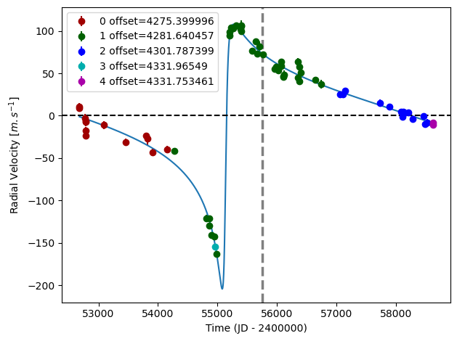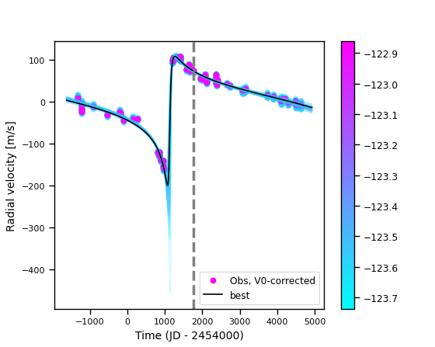

Figure 1: Left: fit of the HD 98649 RV with DPASS. Red (resp. green, blue, cyan and purple) points correspond to the C98 (resp. C07, C14, H03 and H15) data. The blue curve shows the best fit. Right: fit of the HD 98649 RV using MCMC. The black curve shows the best fit. The colorbar corresponds to the log-likelihood of the fits. The gray dotted line indicates the end of the CH survey.

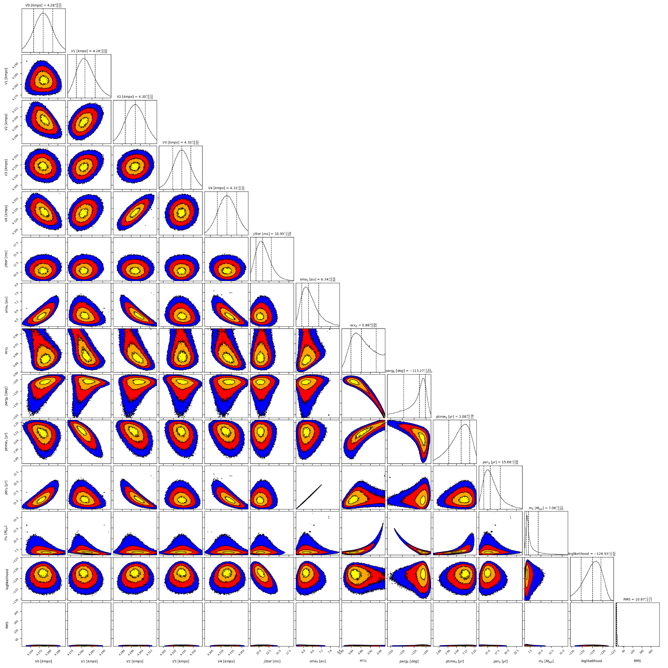

Figure 2: Corner plot of posteriors for the one-planet model MCMC fit of HD 98649 RV data.

| Parameter | Priors | | Posteriors | | CH survey |
| --- | --- | --- | --- | --- | --- |
|  | DPASS | MCMC | DPASS | MCMC |  |
| *a* (au) | [0,100] | [1,20] | 6.3 | 6.3+0.7-0.4 | 9.4 |
| Msin(i) (MJup) | [0,100] | [0.1,15] | 7 | 6.6 – 9.4 | 7 |
| Eccentricity | [0,0.95] | [0.5,0.95] | 0.87 | 0.84 – 0.95 | 0.86 |
| Instrumentals offsets (m/s) | [-60,60] | [2,5] | C98: 4.275  C07: 4.282  C14: 4.302  H03: 4.332  H15: 4.332 | C98: 4.275 ± 0.008  C07:  C14: 4.300 ± 0.009  H03: 4.332 ± 0.014  H15: 4.329 ± 0.014 |  |
| Stellar jitter (m/s) | [0,40] | [0,40] | 8.5 |  |  |
| Argument of periastron (°) | [0,360] | [0,360] | 249 |  |  |
| Phase | [0,1] | [0,1] | 0.79 |  |  |

Table 1: HD 98649. Summary of priors and posteriors obtained with DPASS and MCMC, compared to the properties reported by the CH Survey.

References

1. Rickman, E. et al. The CORALIE survey for southern extrasolar planets, XVIII. Three new massive planets and two low-mass brown dwarfs at greater than 5 AU separation. Astron. Astrophys. 625, A71 (2019).
2. Li, Y. et al. Precise Masses and Orbits for Nine Radial-velocity Exoplanets. Astron. J. 162, 266 (2021).